SLU Risk Assessment of Plant Pests | SLU.ua.2025.4.2-2422  June 27, 2025

Swedish risk ranking of plant pests: additional species assessed – Report no. 3, 2025

Authors
This report was prepared by SLU Risk Assessment of Plant Pests at the Swedish University of Agricultural Sciences:
Niklas Björklund, Dept. of Ecology, Swedish University of Agricultural Sciences, P.O. Box 7044, SE-750 07 Uppsala, Sweden. Visiting address: Ullsväg 16, E-mail: Niklas.Bjorklund@slu.se
Johanna Boberg, Dept. of Forest Mycology and Plant Pathology, Swedish University of Agricultural Sciences, PO Box 7026, SE-750 07 Uppsala, Sweden. Visiting address: Almas allé 5, E-mail: Johanna.Boberg@slu.se

Recommended citation:
Björklund, N. & Boberg, J. (2025) Swedish risk ranking of plant pests: additional species assessed – Report no. 3, 2025. Technical report. SLU.ua.2025.4.2-2422. SLU Risk Assessment of Plant Pests, Swedish University of Agricultural Sciences. Available from www.slu.se/risk-assessment

The Swedish risk ranking of plant pests project
SLU Risk Assessment of Plant Pests was requested by the Swedish Board of Agriculture (NPPO) to conduct a risk ranking of a target group of plant pests relevant to Sweden from a phytosanitary perspective. The risk ranking model FinnPRIO (Heikkilä et al. 2016) is used for the assessments and subsequent rankings. A description of the project aim, scope and methodology is presented in another report, i.e. Boberg and Björklund (in prep).
This report presents the results of FinnPRIO assessments for a new batch of 13 new species that were subsequently ranked together with 80 previously assessed species.
The following 13 species have now been added:
- Acleris minuta [ACLRMI]
- Acleris nishidai [ACLRNI]
- Acleris nivisellana [ACLRNV]
- Acleris semipurpurana [CROISE]
- Acleris senescens [ACLRSE]
- Anoplophora glabripennis [ANOLGL]
- Choristoneura conflictana [ARCHCO]
- Choristoneura pinus [CHONPI]
- Choristoneura rosaceana [CHONRO]
- Diabrotica undecimpunctata howardi [DIABUH]
- Oemona hirta [OEMOHI]
- Porphyrophora tritici [PORPTR]
- Prodiplosis longifila [PRDILO]
A complete list of all assessed species and date of the assessments can be found in Appendix 1.

Results
The pest scores calculated for each of the FinnPRIO components (Entry, Establishment & Spread, Impact, Preventability and Controllability) along with the composite Invasion scores (Entry × Establishment & Spread) and Risk scores (Entry × Establishment & Spread × Impact) are presented in three figures below. Interactive versions of the figures are available as HTML-files by clicking on the symbol adjacent to the figure. The interactive figure includes information about which pest each dot in the figure refer to and it allows filtering of the data, e.g., showing only the results from pests belonging to a certain category. The dots in the figures represent the mean values of 25 000 iterations and the whiskers represent the 5th and 95th percentiles of the probability distributions of the scores. Abbreviations following Bursaphelenchus xylophilus refer to current climate (CC) and future climate (FC).

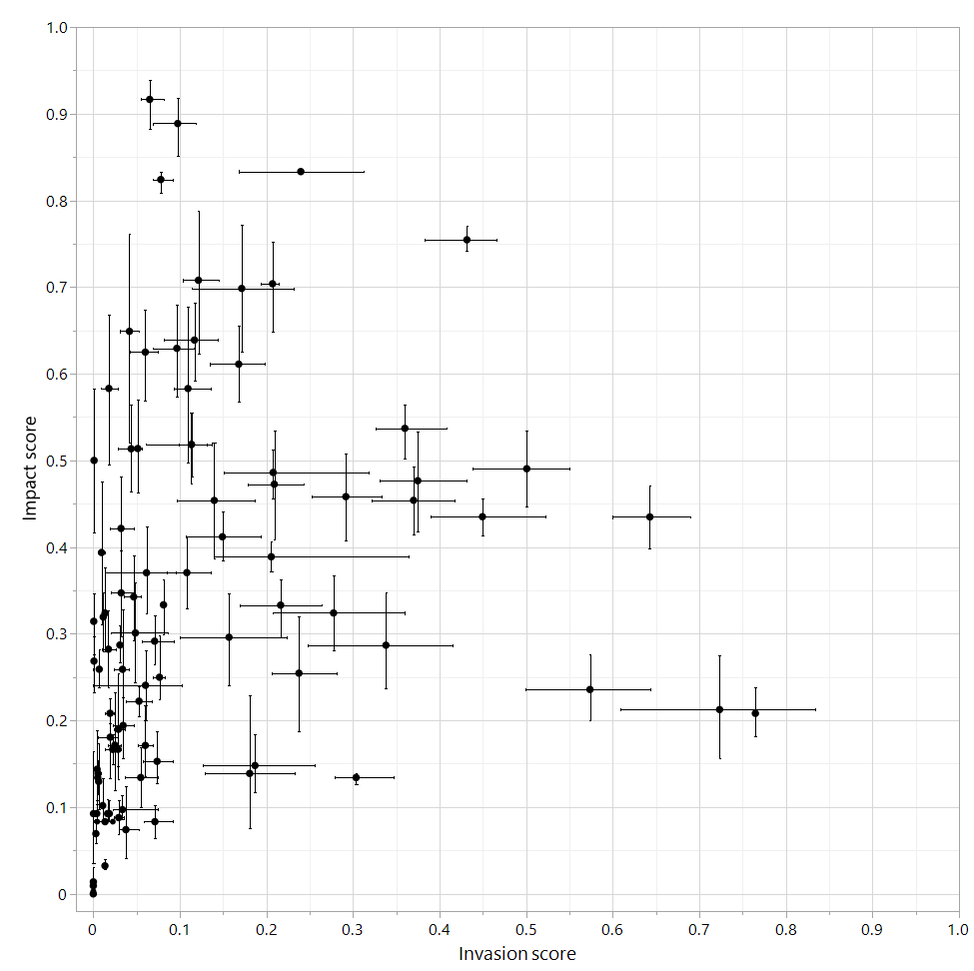
Figure 1. The risk of each pest is visualized by plotting the likelihood of invasion scores (Entry × Establishment & Spread) against the scores for Impact for each assessed pest.

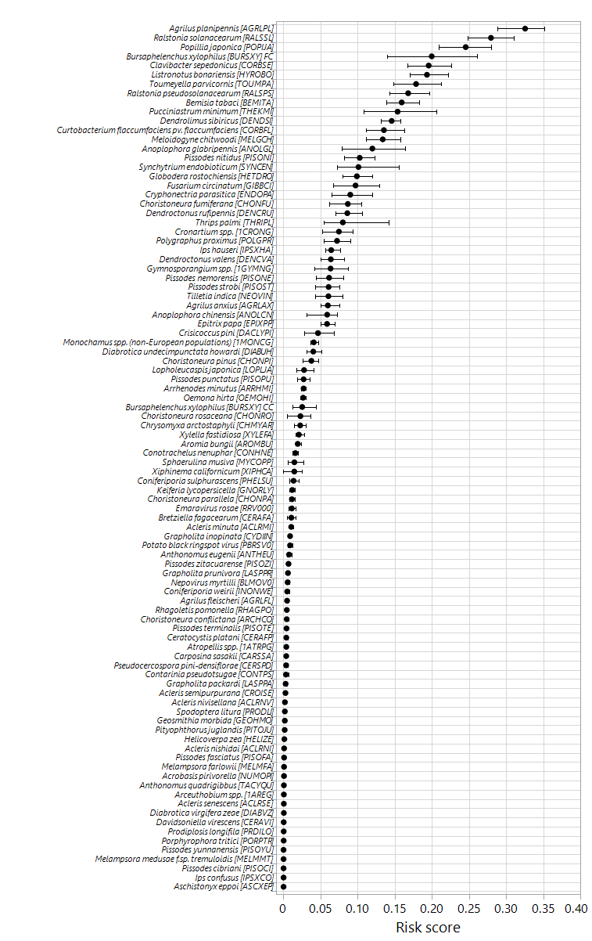

Figure 2. FinnPRIO Risk scores. Note that the components of manageability are not included in the Risk score (scores for these components are provided in Figure 3).
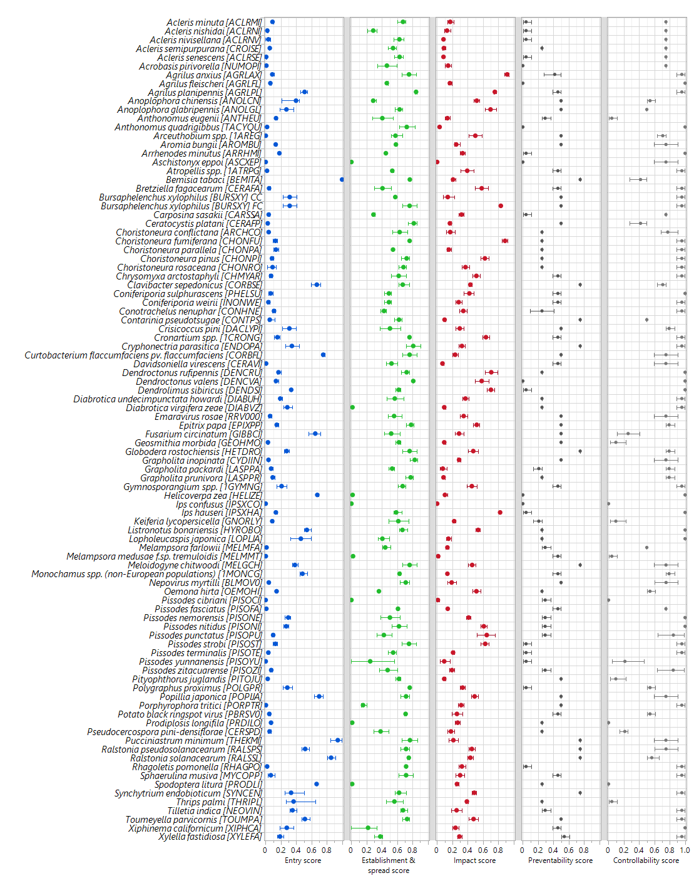
Figure 3. FinnPRIO component scores.

References
Boberg, J. and Björklund, N. Project report - Swedish Risk Ranking of Plant Pests (SweRRPP). Technical report SLU.ua.2022.2.6-4500. SLU Risk Assessment of Plant Pests, Swedish University of Agricultural Sciences. In prep.
Heikkilä, J., Tuomola, J., Pouta, E., & Hannunen, S. (2016). FinnPRIO: a model for ranking invasive plant pests based on risk. Biological Invasions, 18(7), 1827-1842. https://doi.org/10.1007/s10530-016-1123-4

Appendix 1. List of all the assessed species/genera and date of assessment
Pest name | EPPO code | Assessment date
Acleris minuta | ACLRMI | 18.06.2025
Acleris nishidai | ACLRNI | 18.06.2025
Acleris nivisellana | ACLRNV | 18.06.2025
Acleris semipurpurana | CROISE | 18.06.2025
Acleris senescens | ACLRSE | 18.06.2025
Acrobasis pirivorella | NUMOPI | 08.10.2021
Agrilus anxius | AGRLAX | 31.03.2021
Agrilus fleischeri | AGRLFL | 11.06.2021
Agrilus planipennis | AGRLPL | 04.06.2021
Anoplophora chinensis | ANOLCN | 05.05.2021
Anoplophora glabripennis | ANOLGL | 18.06.2025
Anthonomus eugenii | ANTHEU | 11.06.2021
Anthonomus quadrigibbus | TACYQU | 17.05.2021
Arceuthobium spp. | 1AREG | 20.03.2025
Aromia bungii | AROMBU | 11.06.2021
Arrhenodes minutus | ARRHMI | 31.05.2021
Aschistonyx eppoi | ASCXEP | 10.06.2021
Atropellis spp. | 1ATRPG | 16.06.2021
Bemisia tabaci | BEMITA | 28.05.2021
Bretziella fagacearum | CERAFA | 29.04.2021
Bursaphelenchus xylophilus (Current Climate) | BURSXY | 05.05.2021
Bursaphelenchus xylophilus (Future Climate) | BURSXY | 28.04.2021
Carposina sasakii | CARSSA | 13.06.2021
Ceratocystis platani | CERAFP | 01.02.2022
Choristoneura conflictana | ARCHCO | 17.06.2025
Choristoneura fumiferana | CHONFU | 13.08.2024
Choristoneura parallela | CHONPA | 13.08.2024
Choristoneura pinus | CHONPI | 17.06.2025
Choristoneura rosaceana | CHONRO | 17.06.2025
Chrysomyxa arctostaphyli | CHMYAR | 08.02.2022
Clavibacter sepedonicus | CORBSE | 19.03.2025
Coniferiporia sulphurascens | PHELSU | 06.05.2021
Coniferiporia weirii | INONWE | 06.05.2021
Conotrachelus nenuphar | CONHNE | 11.06.2021
Contarinia pseudotsugae | CONTPS | 14.06.2021
Crisicoccus pini | DACLYPI | 28.03.2022
Cronartium spp. | 1CRONG | 29.06.2021
Cryphonectria parasitica | ENDOPA | 29.06.2021
Curtobacterium flaccumfaciens pv. flaccumfaciens | CORBFL | 20.03.2025
Davidsoniella virescens | CERAVI | 02.02.2022
Dendroctonus rufipennis | DENCRU | 30.06.2021
Dendroctonus valens | DENCVA | 30.06.2021
Dendrolimus sibiricus | DENDSI | 24.09.2021
Diabrotica undecimpunctata howardi | DIABUH | 18.06.2025
Diabrotica virgifera zeae | DIABVZ | 17.03.2025
Emaravirus rosae | RRV000 | 13.08.2024
Epitrix papa | EPIXPP | 11.06.2021
Fusarium circinatum | GIBBCI | 13.08.2024
Geosmithia morbida | GEOHMO | 10.02.2022
Globodera rostochiensis | HETDRO | 11.06.2021
Grapholita inopinata | CYDIIN | 23.06.2021
Grapholita packardi | LASPPA | 18.08.2021
Grapholita prunivora | LASPPR | 16.06.2021
Gymnosporangium spp. | 1GYMNG | 07.06.2021
Helicoverpa zea | HELIZE | 17.03.2025
Ips confusus | IPSXCO | 08.10.2021
Ips hauseri | IPSXHA | 05.01.2022
Keiferia lycopersicella | GNORLY | 13.08.2024
Listronotus bonariensis | HYROBO | 17.03.2025
Lopholeucaspis japonica | LOPLJA | 20.03.2025
Melampsora farlowii | MELMFA | 26.05.2021
Melampsora medusae f.sp. tremuloidis | MELMMT | 29.08.2024
Meloidogyne chitwoodi | MELGCH | 11.06.2021
Monochamus spp. (non-European populations) | 1MONCG | 28.04.2021
Nepovirus myrtilli | BLMOV0 | 13.08.2024
Oemona hirta | OEMOHI | 18.06.2025
Pissodes cibriani | PISOCI | 15.08.2024
Pissodes fasciatus | PISOFA | 15.08.2024
Pissodes nemorensis | PISONE | 14.08.2024
Pissodes nitidus | PISONI | 15.08.2024
Pissodes punctatus | PISOPU | 14.08.2024
Pissodes strobi | PISOST | 03.05.2021
Pissodes terminalis | PISOTE | 14.08.2024
Pissodes yunnanensis | PISOYU | 14.08.2024
Pissodes zitacuarense | PISOZI | 14.08.2024
Pityophthorus juglandis | PITOJU | 20.09.2021
Polygraphus proximus | POLGPR | 13.08.2024
Popillia japonica | POPIJA | 29.04.2025
Porphyrophora tritici | PORPTR | 17.06.2025
Potato black ringspot virus | PBRSV0 | 29.04.2021
Prodiplosis longifila | PRDILO | 17.06.2025
Pseudocercospora pini-densiflorae | CERSPD | 13.08.2024
Pucciniastrum minimum | THEKMI | 13.08.2024
Ralstonia pseudosolanacearum | RALSPS | 19.03.2025
Ralstonia solanacearum | RALSSL | 19.03.2025
Rhagoletis pomonella | RHAGPO | 11.06.2021
Sphaerulina musiva | MYCOPP | 13.08.2024
Spodoptera litura | PRODLI | 17.03.2025
Synchytrium endobioticum | SYNCEN | 29.04.2021
Thrips palmi | THRIPL | 19.03.2025
Tilletia indica | NEOVIN | 19.03.2025
Toumeyella parvicornis | TOUMPA | 30.04.2025
Xiphinema californicum | XIPHCA | 11.06.2021
Xylella fastidiosa | XYLEFA | 20.03.2025

