SLU Risk Assessment of Plant Pests | SLU.ua.2022.2.6-4500  Mars 27, 2026

Project report:
Swedish risk ranking of plant pests

Authors
This report was prepared by:
SLU Risk Assessment of Plant Pests, Swedish University of Agricultural Sciences
Webpage: www.slu.se/risk-assessment
Johanna Boberg, Dept. of Forest Mycology and Plant Pathology, Swedish University of Agricultural Sciences, PO Box 7026, SE-750 07 Uppsala, Sweden. Visiting address: Almas allé 5, E-mail: Johanna.Boberg@slu.se
Niklas Björklund, Dept. of Ecology, Swedish University of Agricultural Sciences, P.O. Box 7044, SE-750 07 Uppsala, Sweden. Visiting address: Ullsväg 16, E-mail: Niklas.Bjorklund@slu.se

Recommended citation:
Boberg, J. and Björklund, N. (2026) Project report - Swedish risk ranking of plant pests. Technical report SLU.ua.2022.2.6-4500. SLU Risk Assessment of Plant Pests, Swedish University of Agricultural Sciences. Available from www.slu.se/risk-assessment

Acknowledgement
We would like to thank Pernilla Borgström, Eva Edin, E. Petter Axelsson and Ramesh R. Vetukuri for their contributions to the data gathering for the different organism groups performed during 2018 and 2019 as follows: insects and mites associated with agricultural systems (Pernilla), nematodes (Eva), insects and mites associated with trees (Petter) and bacteria, fungi, and viruses (Ramesh). All experts were employed by the Swedish University of Agricultural Sciences (SLU). We also gratefully acknowledge all the help, support, and advice on using the FinnPRIO model provided by Juha Tuomola, Salla Hannunen and Mariela Marinova-Todorova from the Finnish Food Authority.
We would also like to thank Johan A. Stenberg (Swedish University of Agricultural Sciences), Juha Tuomola (Finnish Food Authority), and Daniel Flø (Norwegian Scientific Committee for Food and Environment) for reviewing a draft version of the report.

Contents
Summary 4
1. Background 5
2. Methodology 6
FinnPRIO risk ranking model 6
Adaptions and settings 6
Procedure 8
3. Results and discussion 8
4. References 15
Appendix 1. Instructions used for the FinnPRIO assessments 17
Appendix 2. Filtering options in HTML-versions of the figures 36
Appendix 3. List of all the assessed species/genera and date of assessment 37
Appendix 4. Summary statistics 40

Summary
In the project, Swedish risk ranking of plant pests, regulated plant pests relevant to Sweden will be assessed and ranked to provide scientific-based information on the risk that these pests may constitute for plant health in Sweden. In addition, non-regulated pests may also be included to evaluate the risk they constitute for Sweden. This report describes the methodology used and presents the results of the pests ranked to date (Section 3 and Appendix 3).
The FinnPRIO model, used in this project, enables rapid assessments and ranking of plant pests based on different components included in Pest Risk Analyses (PRAs), i.e. the likelihoods of entry, establishment & spread, magnitude of impact and feasibility of management. The model was developed for Finland and could be used for Sweden with minor amendments to the instructions. The instructions guide the selection of suitable answer options to the questions on which the model is based. All amendments done are shown in Appendix 1. Assessments were conducted for 108 plant pests and scores for each component and risk (Entry × Establishment & Spread × Impact) are presented. Different aspects of the model and the interpretation of the results that are important to take into consideration when using the information are outlined. New pests will be assessed and ranked on an ongoing basis.
Risk ranking of plant pests at national level, such as the risk score described in this report, provides valuable information to support plant health risk management decisions and resource allocation. Since risk ranking is based on quick risk assessments, additional in-depth analysis may be required in certain cases to provide further justifications prior to decision-making on plant health risk management level.

Background
Preventive actions against EU quarantine pests are an important component of national plant health risk management. Regular surveys for these pests are for example performed to enable detection of an outbreak at an early stage. Analysing and evaluating whether new pests fulfil the criteria to become regulated using pest risk analysis is another central activity. These types of preventative activities are very resource demanding and the risk that different pests constitute differ between countries. The high number of pests in relation to available resources do not allow performing full pest risk assessments for all pests at the national level. Quick risk assessments are therefore needed to compare the risk posed by different pests and to support prioritization of resources and risk management decisions.
SLU Risk Assessment of Plant Pests was requested by the Swedish Board of Agriculture (NPPO) to conduct a risk ranking of all regulated plant pests relevant to Sweden as well as for some pests that currently are not regulated but that may fulfill the criteria to become regulated. The main aim of the risk ranking is to enable the prioritization of resources to pests with the highest associated risk to Sweden.
More specifically the ‘Swedish risk ranking of plant pests’ project aims to provide evidence-based assessments that could support risk management actions related to:
- Prioritization of resources for survey of different pests in Sweden.
- Prioritization of resources for inspections of pathways (import control, inspection at nurseries, market control).
- Identification of pests for further risk assessments, such as PRAs to evaluate whether the pest potentially fulfills the criteria to become regulated.
- Identification of pests for which contingency plans or specific management plans may be developed.
- A knowledge base for communicating information concerning areas of responsibility and management actions to relevant stakeholders.
- A knowledge base for communicating information to the general public.
- Identification of the main uncertainties of the risk assessments, which could translate into questions for which further research is needed.
Numerous models have been developed for this purpose representing different methods to score and/or rank plant pests according to their risk (e.g., Baker et al. 2014; Heikkilä et al. 2016; van der Gaag et al. 2017; Tayeh et al. 2021; EFSA et al. 2022). Although the specific purpose of the models may differ, they generally have similar features and often developed with similar general objectives to facilitate decisions and prioritize among actions. The models usually follow the principles of a PRA (ISPM2, ISPM11) but are often based on quick assessments and within a framework that aims to improve consistency to facilitate direct comparisons between pests (see, e.g., review by EFSA et al. (2021)).
Previously, an evaluation of a selection of available risk ranking models was performed based on the above-mentioned requirements (SLU Risk assessment of plant pests 2017). The risk ranking model FinnPRIO (Heikkilä et al. 2016) developed in Finland was considered to best suit the needs in Sweden. The current report presents the ‘Swedish risk ranking of plant pests’ project and provides a description of the methodology used and the results of the plant pests ranked to date (Appendix 3).

Methodology

FinnPRIO risk ranking model
The FinnPRIO model ranks invasive plant pests according to the relative risk they pose to a country (Heikkilä et al. 2016). FinnPRIO was developed for Finland but can be adapted to other countries. The model allows for rapid assessments, and the assessment of each pest was orginally estimated to take approximately 4 – 16 hours to complete. However, much more time has been spent on many of the species included in the current project.
FinnPRIO follows the basic structure of a full PRA and assessments are done for the components ‘likelihood of entry’ (hereafter refered to as Entry), ‘likelihood of establishment and spread’ (Establishment & Spread), ‘potential impact’ (Impact) as well as for ‘manageability’ (Preventability and Controllability). Semi-quantitative assessments are obtained by answering a set of multiple-choice questions where each answer option carries a predefined value that is used to calculate a score for each component. A justification with references should be provided for each question to support the selected answer option. An estimation of the uncertainty of the assessments is also included in the model, where for each question, the most likely answer option as well as the plausible minimum and maximum answer options are assigned. These are then used to define a PERT probability distribution for the answers to each question, which are then used in Monte Carlo simulations to generate a probability distribution of each component score. The summary statistics, for example the mean values and the 5th and 95th percentile of each probability distribution of the scores, can then be plotted to visualize the results for all assessed pests.
The assessed pests can be ranked based on the scores for each component or based on the overall risk score, i.e., a combination of the scores. The scores for the components Entry and Establishment & Spread are multiplied to obtain an Invasion score. The Invasion score multiplied by the score for the component Impact provides a score for the Risk. The score for Manageability is defined as the lowest score of the components Preventability or Controllability, and the assessed pests can also be ranked based on the score for any of these components. A full description of the FinnPRIO model and the calculations done to obtain the different scores can be found in Heikkilä et al. (2016).

Adaptions and settings
The FinnPRIO assessments for the Swedish risk ranking were initially performed using the graphical user interface of the model (i.e., FinnPRIO GUI) developed by Marinova-Todorova et al. (2019) and later performed using the FinnPRIO Assessor application (Ruete et al. 2025a). Finland and Sweden are to a large degree similar in terms of plant production systems used and environmental conditions affecting the risk of plant pests, although it is acknowledged that the conditions in southern Sweden differs. Rescaling some of the answer options related to Entry, Establishment & Spread and Impact to adapt FinnPRIO to other countries was suggested by Heikkilä et al. (2016). However, since the range of trade volumes and host plant areas is relatively similar in size between the two countries (e.g., Ekström and Hannerz 2020), no rescaling was deemed necessary (see Appendix 1). The FinnPRIO model could thus be used for Sweden with only minor amendments to the instructions that define the questions and answer options. The answer options related to climate suitability question EST1 was adapted to suit the climate in Sweden and further clarifications to some questions and answer options were added, most of them following personal communication with J. Tuomola and M. Marinova-Todorova (Finnish Food Authority 2016-2018). The instructions used for the ‘Swedish risk ranking of plant pests’ project, including the amendments done, are provided in Appendix 1.
The model calculations were run with 50 000 iterations, and the PERT distribution used a lambda value of 4 as in Heikkilä et al. (2016). Equal weighting of the scores obtained in the i) economic and ii) combined environmental and social impact sections was used in the calculations as decided by the risk managers at the Swedish NPPO. This setting may however be adjusted in the future. All FinnPRIO scores generated by the current version of the FinnPRIO model are normalized to a scale from 0–1 (Marinova-Todorova et al. 2019). The FinnPRIO scores were generated using the FinnPRIO Assessor application (Ruete et al. 2025a).
There are different ways to rank the pests based on the scores and the probability distribution obtained from the FinnPRIO model. In Heikkilä et al. (2016) the Risk score for the pests were generated by ranking the pests in each iteration providing a probability distribution (i.e., reflecting the uncertainty of the score) of the ranks received by each pest. In other applications of the FinnPRIO model, the pests are compared and ranked taking into account the whole probability distribution using the hypervolume approach (Yemshanov et al. 2017; Tuomola et al. 2018; Marinova-Todorova et al. 2020). This approach ranks the pests based on statistical differences in the probability distribution of scores. The uncertainty is thereby taken into account in the ranking, but this also means that the uncertainty associated with the assessment for each pest is not visible in the output ranks. In addition, in the hypervolume approach the ranking needs to be re-computed each time a new pest is included and it is not feasible to produce plots of the invasion x impact of the type shown in Figure 1. Considering the purpose of this project and the expected application of the results, the assessed pests were here ranked using the summary statistics of the distribution of the FinnPRIO scores. The hypervolume approach may however be used in the future should a statistically-based separation of the ranked pests be required.

Procedure
All EU quarantine plant pests (Annex II of (EU) 2019/2072) relevant for Sweden will be assessed and ranked in the project. Excluded are pests that already have been assessed not to be able to establish or spread in Sweden due to e.g., the ecoclimatic conditions or lack of hosts as described in other projects (e.g., Björklund and Boberg 2021, 2023; Boberg and Björklund 2025). In addition, upon request from the Swedish NPPO, pests that are not regulated as EU quarantine pests may also be included to evaluate the relative risk they constitute for Sweden and whether the pest may fulfill the criteria to become regulated. This could for example include pests highlighted by EPPO (Alert list and A1/A2 lists) and other pests that are non-native to Sweden, and which have recently been intercepted, and with plant hosts that are of significance to Sweden.
Assessments were preferably conducted at the species level. Pests regulated at a group level (e.g., Cronartium spp.) were in most cases also assessed together, with the scores reflecting the species within the group with the highest ratings. The assessments were generally performed considering the current climate. One exception was made for the pine wood nematode (Bursaphelenchus xylophilus) for which increasing temperatures is expected to have a decisive influence on symptom development (e.g., Ikegami and Jenkins 2018). A separate assessment considering a future climate was thus also included. Eighteen species were selected to harmonize the ratings between e.g., different groups of pests, with the goal to ensure consistency and comparability in the risk ranking outcomes. The selection of pests aimed to include all different organism groups, plant production systems, and levels of expected relevance to Sweden in order to span a broad range of outcomes of the risk ranking. This set of species was then used as reference points for assessing all other pests.
Summary statistics of the assessment scores for each pest were extracted and visualized using the FinnPRIO Explorer Adapted application (Figure 1; Ruete et al. (2025b) and JMP® Software (Figure 2 and 3). To make it easier to compare groups of pests, e.g., affecting a certain plant production system, HTML-versions of the JMP-figures were created which allow filtering based on different criteria (Appendix 2).

Results and discussion
Results of FinnPRIO assessments for 108 plant pest species/genera are presented in this report. Most pests are insects or fungi regulated as quarantine pests in the EU. The exceptions are Agrilus fleischeri, Contarinia pseudotsugae and Crisicoccus pini which are, or have been, on the EPPO Alert List (https://www.eppo.int/ACTIVITIES/plant_quarantine/alert_list)), Melampsora medusa f. sp. tremuloidis, which was recently deregulated following Commission Implementing Regulation (EU) 2024/2004 as well as Toumeyella parvicornis and Pucciniastrum minimum, both listed on the A2-list of EPPO. The latter is also a regulated non-quarantine pest in the EU.
The risk posed by each pest to Sweden is visualised by plotting the scores for Invasion (Entry × Establishment & Spread) against the scores for Impact (Figure 1). In general, pests with the lowest risk are found in the lower left corner of the plot (low scores for both Invasion and Impact) while pests with the highest risk are found in the upper right corner (high scores for both Invasion and Impact). The FinnPRIO scores for invasion in this report take into account the official management measures applicable at the time of carrying out the FinnPRIO assessments, e.g., requirements applicable to traded commodities to prevent the entry of quarantine pests and import prohibitions for certain plants set out in for example regulations (EU) 2019/2072 and (EU) 2018/2019. For most pests, these measures decrease the likelihood of entry compared to a scenario without such measures, which results in the scores of the assessed pests being shifted to the left in the plot. In general, it is strongly suggested that the answer options for the questions belonging to the different components of the FinnPRIO assessments are explored to better understand what the results represent (Appendix 1).
The Risk score, which combines the scores for Invasion and Impact, can also be plotted (Figure 2). It should be noted that since the Risk score combines the scores for Invasion and Impact two pests can have similar Risk scores where one has a high score for Invasion and a low score for Impact, while the other has a low score for Invasion and a high score for Impact. This is for example the case for Bemisia tabaci vs. Dendrolimus sibiricus (Figure 1). Further, it should be noted that the scores for the components named Preventability and Controllability are not included in the Risk score but may be important to take into consideration when taking risk management decisions. For example, although B. tabaci received a high score for Risk, it is not as difficult to eradicate after establishment as many other pests (cf. Controllability score, Figure 3).

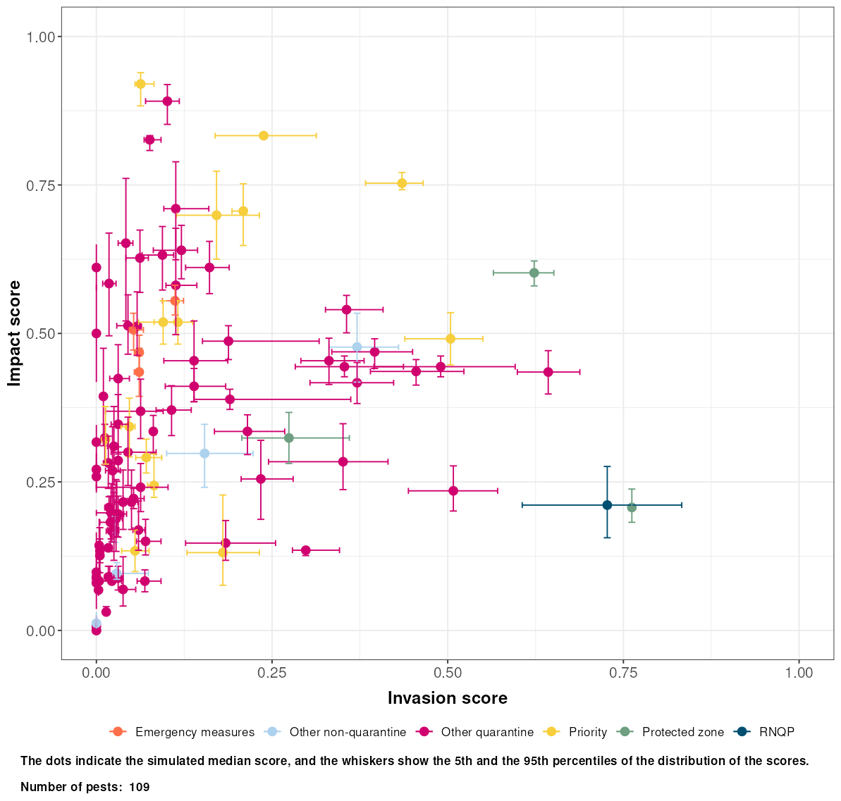
Figure 1. The risk of each pest is visualized by plotting the likelihood of invasion scores (Entry × Establishment & Spread) against the scores for Impact for each assessed pest. The dots represent the median values of 50 000 iterations and the whiskers represent the 5th and 95th percentiles of the probability distributions of the scores. The figure was downloaded 2026-03-19 from the FinnPRIO Explorer Adapted application (Ruete et al. 2025b).
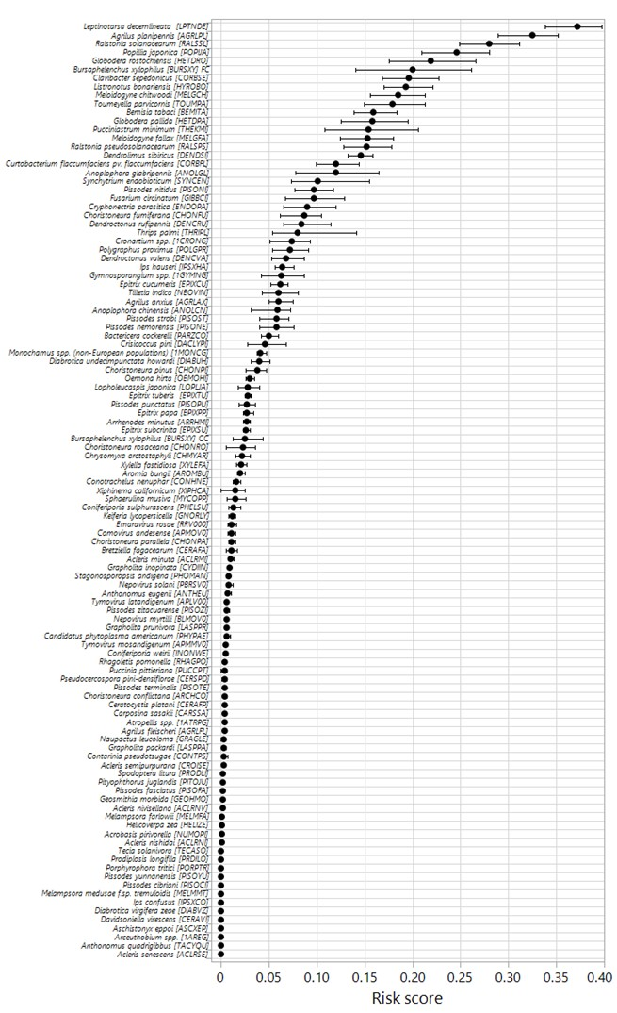
Figure 2. FinnPRIO Risk scores for the assessed pests (i.e. Entry score × Establishment & Spread score × Impact score). Note that the components of manageability are not included in the Risk score (scores for these components are provided in Figure 3). The dots represent the mean values and the whiskers represents the 5th and 95th percentiles of the probability distributions of the scores. The pest’s scientific name is followed by the EPPO code in brackets. Abbreviations following Bursaphelenchus xylophilus refer to current climate (CC) and future climate (FC). An interactive version of the figure is available as an HTML-file by clicking on the symbol to the right. Information about the filtering categories is available in Appendix 2.
When interpreting the figures, it is important to remember that the scores are based on quick assessments and a limited set of questions and that the answer options are specifically defined (see Appendix 1). In addition, the main aim of the FinnPRIO model is to enable ranking of pests and the absolute values per se that a specific pest obtains provides limited information. Further, since the pests were ranked based on the summary statistics of the probability distributions of the scores, the absolute position of each pest in the plots will not be affected by other pests included in the analysis, but its relative position may be influenced and thereby potentially the interpretation. The FinnPRIO scores can be plotted based on any one of the summary statistics. The mean values of the calculated score distributions are used in figure 2 and 3 and corresponds to the expected value of the full distribution derived from the plausible minimum, most likely, and plausible maximum estimates. The mean may, however, be considered overly sensitive to the minimum and maximum assessments. An alternative, which addresses this concern, is to use the median (used in Figure 1), but one drawback of that approach is that pests with very low mean values often have a median of zero (Appendix 4). Another alternative is to use the 95th percentile which highlights worst-case scenarios and thus represents a precautionary approach, but it is based solely on the highest 5 % of simulated scores and is therefore strongly biased toward unlikely scenarios, ignoring the information contained in the remaining 95 % of the distribution.
It is important to note that the assessments of direct losses (IMP1) assume pest presence throughout the entire threatened area, i.e. the area where hosts are present and where the pest can reproduce and overwinter given the climatic and production conditions. The estimates are made in absolute monetary terms (EUR), and not in relation to the economic size of the particular plant sectors. This means that pests causing proportionally large losses to small plant sectors will still be rated relatively low compared to for example pests causing proportionally similar losses to the forest sector, which is very large in Sweden. Comparisons within each sector can be facilitated by creating separate lists or by filtering the pests according to the specific plant sectors they are relevant for (see interactive figures).
The FinnPRIO scores for each component of the model are visualized in Figure 3. Here, the individual scores for Entry and Establishment & Spread are displayed together with the scores for Impact. High scores reflect a high likelihood of entry, high likelihood of establishment (and spread), and a high potential impact. Scores of the individual components are difficult to interpret when used in isolation but interpreted together can provide valuable information when making risk management decisions, as mentioned earlier. The results for Preventability and Controllability, which represent components of manageability, are also plotted in the same figure. High scores for these components reflect the relative difficulty to prevent and control a pest invasion, respectively. A high proportion of the assessed pests have maximum, or close to maximum, scores for Controllability. This is because many of the pests included here are pests of forest trees and will be difficult to survey and thereby they score high for question MAN5 based on the definition of the answer options (Appendix 1).
To conclude, the assessments and ranking provided by FinnPRIO aim to provide a valuable resource of information that can be used to support risk management decisions and activities. The project is ongoing, with the goal of assessing and ranking all quarantine pests and other plant pests that are of phytosanitary relevance for Sweden.
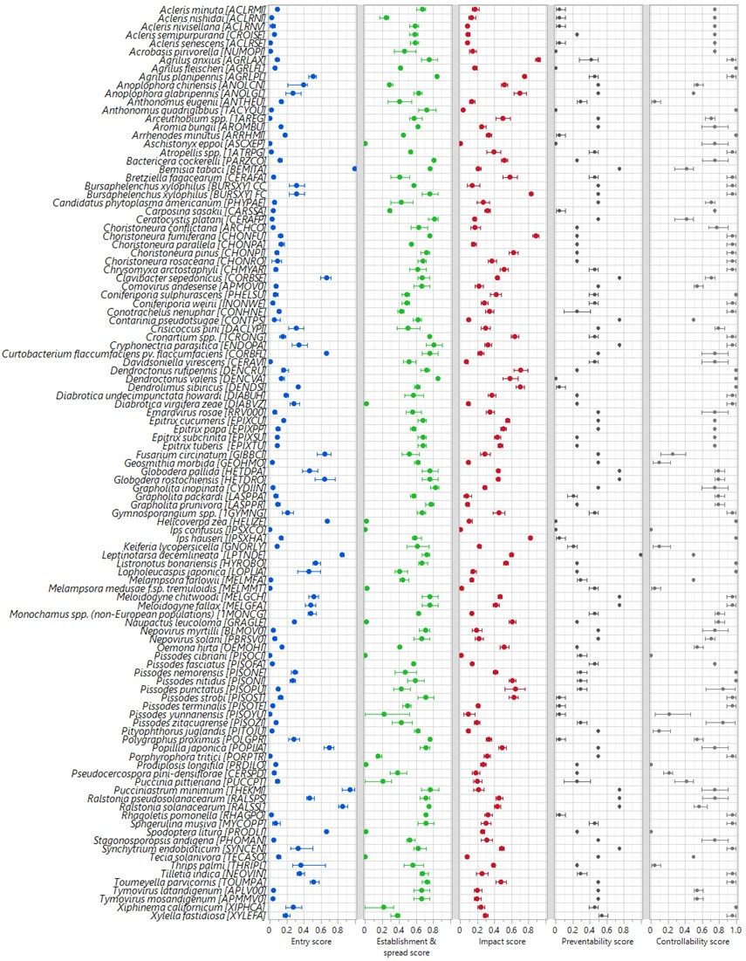Figure 3. FinnPRIO scores for each component of the FinnPRIO model. The dots represent the mean values and the whiskers represents the 5th and 95th percentiles of the probability distributions of the scores. Abbreviations following Bursaphelenchus xylophilus refer to current climate (CC) and future climate (FC). An interactive version of the figure is available as a HTML-file by clicking on the symbol above. Information about the filtering categories is available in
Appendix 2.

References
Baker, R. H. A., Anderson, H., Bishop, S., MacLeod, A., Parkinson, N., and Tuffen, M. G. (2014). The UK Plant Health Risk Register: a tool for prioritizing actions. EPPO Bulletin, 44(2), 187-194. https://doi.org/10.1111/epp.12130

Björklund, N. and Boberg, J. (2021) Quick assessments of the potential for establishment in Sweden for a selection of quarantine pests. Technical report SLU ua 2020.2.6-4656. SLU Risk Assessment of Plant Pests, Swedish University of Agricultural Sciences. https://res.slu.se/id/publ/122550
Björklund, N. and Boberg, J. (2023) Quick assessments of the potential for establishment in Sweden for a selection of new quarantine pests in 2022. Technical report SLU.ua.2022.2.6-3074. SLU Risk Assessment of Plant Pests, Swedish University of Agricultural Sciences. https://res.slu.se/id/publ/122548
Boberg, J. and Björklund, N. (2025) Quick assessments of the potential for establishment in Sweden for the provisional quarantine pests Chloridea virescens, Homona magnanima, Resseliella citrifrugis, and Spodoptera ornithogalli. Technical report SLU.ua. 2025.2.6-1671. SLU Risk Assessment of Plant Pests, Swedish University of Agricultural Sciences. https://res.slu.se/id/publ/141842
Björklund, N. and Boberg, J. (2025) Swedish risk ranking of plant pests: additional species assessed – Report no. 3, 2025. Technical report. SLU.ua.2025.4.2-2422. SLU Risk Assessment of Plant Pests, Swedish University of Agricultural Sciences. https://res.slu.se/id/publ/144915
EFSA (European Food Safety Authority), Tayeh C and Mannino MR. (2021) A review of ranking systems for new plant threats in EU Member States and Third Countries: concepts and applications. EFSA supporting publication 2021:EN-1615. 25pp. https://doi.org/10.2903/sp.efsa.2021.EN-1615
EFSA (European Food Safety Authority), Tayeh C, Mannino MR, Mosbach-Schulz O, Stancanelli G, Tramontini S, Gachet E, Candresse T, Jaques Miret JA and Jeger MJ, (2022) Scientific Report on the proposal of a ranking methodology for plant threats in the EU. EFSA Journal 2022;20(1):7025, 59 pp. https://doi.org/10.2903/j.efsa.2022.7025
Ekström, H., and Hannerz, M. (2020) Nordic Forest Statistics 2020 - Resources, industry, trade, conservation and climate. Nordic Forest Research (SNS) Report available at https://nordicforestresearch.org/wp-content/uploads/2021/03/Nordisk-skogsstatistik.pdf
Heikkilä, J., Tuomola, J., Pouta, E., & Hannunen, S. (2016). FinnPRIO: a model for ranking invasive plant pests based on risk. Biological Invasions, 18(7), 1827-1842. https://doi.org/10.1007/s10530-016-1123-4
Ikegami, M., & Jenkins, T. A. (2018). Estimate global risks of a forest disease under current and future climates using species distribution model and simple thermal model–Pine Wilt disease as a model case. Forest ecology and management, 409, 343-352. https://doi.org/10.1016/j.foreco.2017.11.005

Marinova-Todorova, M., Tuomola, J., Heikkilä, J., & Hannunen, S. (2019). A Graphical User Interface for the FinnPRIO model: A model for ranking plant pests based on risk (Version 1.0). Zenodo. http://doi.org/10.5281/zenodo.2784027. Licensed under CC BY-NC-SA 4.0

Marinova‐Todorova, M., Björklund, N., Boberg, J., Flø, D., Tuomola, J., Wendell, M., & Hannunen, S. (2020). Screening potential pests of Nordic coniferous forests associated with trade in ornamental plants. EPPO Bulletin, 50(2), 249-267. https://doi.org/10.1111/epp.12667

Ruete, A., Björklund, N., & Boberg, J. (2025a). FinnPRIO-Assessor (v2). Zenodo. https://doi.org/10.5281/zenodo.18891593
Ruete, A., Björklund, N., & Boberg, J. (2025b). FinnPRIO-Explorer Adapted (v2). Zenodo. https://doi.org/10.5281/zenodo.18861992
Salling, K. B., & Banister, D. (2010). Feasibility risk assessment of transport infrastructure projects: The CBA-DK Decision Support Model. European Journal of Transport and Infrastructure Research, 10(1), 103–120. https://doi.org/10.18757/ejtir.2010.10.1.2871
SLU Risk assessment of Plant Pests (2017) Rapport – en modell för riskrankning av växtskadegörare för Sverige. Sveriges Lantbruksuniversitet. SLU ua 2017.2.6-3393.
Tayeh, C., Guinehut, D., Lê Van, A., Deguercy, X., Tassus, X., Gachet, E., & Manceau, C. (2021). BiOR2: when pest risk assessment meets computer-based multicriteria analysis for plant pest ranking and management. Biological Invasions, 23(3), 919-934. https://doi.org/10.1007/s10530-020-02411-5
Tuomola, J., Yemshanov, D., Huitu, H., & Hannunen, S. (2018). Mapping risks of pest invasions based on the spatio-temporal distribution of hosts. Management of Biological Invasions (2018) Volume 9, Issue 2: 115–126. https://doi.org/10.3391/mbi.2018.9.2.05
Van der Gaag, D. J., Van Leeuwen, G. C. M., Loomans, A. J. M., Potting, R. P. J., & Verhoeven, J. T. J. (2017). Prioritizing risks for plant health in the Netherlands: a method to rank pests according to their probability of introduction. EPPO Bulletin, 47(1), 69-78. https://doi.org/10.1111/epp.12354

Yemshanov, D., Koch, F. H., Lu, B., Fournier, R., Cook, G., & Turgeon, J. J. (2017). A new hypervolume approach for assessing environmental risks. Journal of environmental management, 193, 188-200. https://doi.org/10.1016/j.jenvman.2017.02.021

Appendix 1. Instructions used for the FinnPRIO assessments
The instructions included in the FinnPRIO GUI (Marinova-Todorova et al. 2019, licensed under https://creativecommons.org/licenses/by-nc-sa/4.0/legalcode) were amended (marked in blue font) as follows. The same license applies to this appendix. The original instructions for the FinnPRIO model are provided in Heikkilä et al. (2016).

Basic info
- Add the EPPO code in brackets, i.e. [XXX], after the pest's name
- Only select the plant sector affected by the pest in the section ‘Most likely threatened sectors in the PRA area’.
- When host plants are native species and occur in the wider environment in Sweden, the category ‘Wild’ plants’ should also be selected (e.g., Betula spp.)
ENTRY
Pathways
Of the pathways of entry listed below, choose those that are considered to be possible for the assessed pest to enter into the PRA area. Up to five pathways may be assessed for one pest. All commodities that are similar with respect to the questions in the entry section can be assessed together as one pathway. When the answers to the questions significantly differ between commodities they should be assessed as separate pathways.
PATHWAYS TYPES | PATHWAYS
Host plant commodities | Seeds (i.e. true seeds)
Plants for planting:
planted plants, potted plants, cuttings, grafts, rootstocks, tubers, bulbs, rhizomes and buds. Soil associated with hosts is included in this pathway.
Wood and wood products:
e.g. wood in the rough, sawlogs, sawn wood, wood chips, firewood, wood packaging material, articles of wood, bark
Food and fodder:
plant parts intended for eating or raw materials for the food or fodder industry
Other living plant parts:
cut flowers and green cuttings, Christmas trees, decorative branches, cones used for decoration
Hitchhiking | Hitchhiking:  other than host plant commodities, transport and passengers, soil in general (i.e. soil not associated with hosts).
Natural spread | Natural spread
Intentional introduction | Intentional introduction:  e.g. biological control agents and pest insects

ENT1. How wide is the current global geographical distribution of the pest?
The answer should be determined by comparing the extent of the pest’s present global distribution to the size of the red circle in the lower left-hand corner of the map.

EXAMPLES OF WHAT THE DIFFERENT OPTIONS MEAN:
- Small
- The distribution is considered small when it is smaller than one red circle on the map.

- Medium
- The distribution is considered medium when it is larger than one but smaller than ten circles on the map.

- Large
- The distribution is considered large when it is larger than ten circles in the lower left-hand corner on the map.
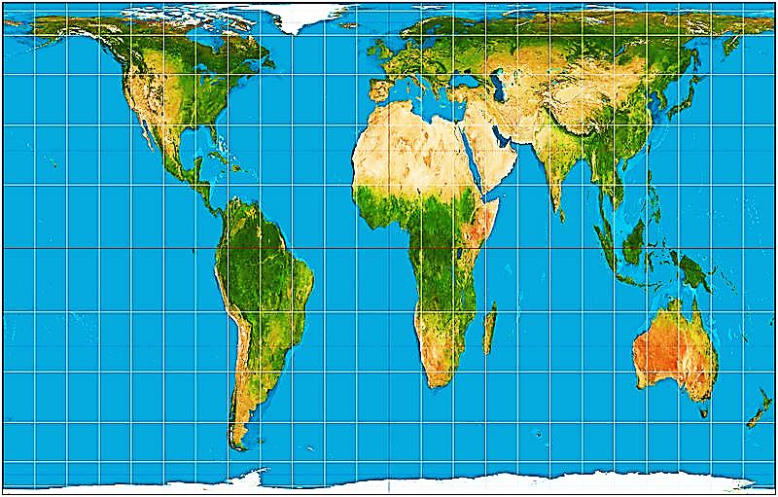
The Gall-Peters projection of the world map

ENT2A. Not taking into account current official management measures, can the pest be transported via the considered pathway?*
- No it cannot
- It can, but it is very unlikely
- It can, but it is unlikely
- It can, and it is likely
- It can, and it is very likely

- The answer options should be used so that they correspond to the same actual probabilities for all the pathways.
- If the pest’s establishment and spread is dependent on its vector species, which is/are not present in the PRA area, the answer should reflect the likelihood with which the vector and the pest could be transported together.

* Following discussions with the Swedish Board of Agriculture, it was decided not to include this question in the ‘Swedish risk ranking of plant pests’ project.

TAKE INTO ACCOUNT
- Factors affecting the pest’s likelihood of being associated with the pathway at the points of origin, e.g.
  - the abundance of the pest in its current range
  - the history of the spread of the pest as a result of human action
  - plant protection measures carried out in the country of origin
  - the detectability of the pest
- Factors affecting the pest’s likelihood of surviving transport via the pathway, e.g.
  - treatments related to export and transport
  - the pest’s potential to survive without a living host plant
  - the pest’s potential to withstand temperature variations, dryness and lack of energy
- Information about interceptions in traded commodities, e.g., data from Europhyt/Traces NT

DO NOT TAKE INTO ACCOUNT
- Whether the considered commodity is traded to the PRA area
- Whether the pest can transfer to a suitable habitat after entering the PRA area
- Whether the pest is able to establish in the PRA area
- The current geographical distribution of the pest (except for natural spread)
- Measures required in legislation on plant health, plant reproductive material or plant protection products

EXAMPLES OF WHAT THE DIFFERENT OPTIONS MEAN
- No it cannot
- The pest cannot survive the transport.
- The treatments of the commodity prevent the movement of the pest along the pathway.
- The considered commodity is not traded internationally.
- The pest’s current distribution is so far from the PRA area that its natural spread to the PRA area is not possible.
- It can, but it is very unlikely
- The pest's biological characteristics, prior spreading history or treatments of the commodity make its transportation very unlikely.
- No interceptions are notified in Europhyt, although the commodity is regularly imported into EU and it is under official surveillance.
- The pest is present in Europe, but not in the neighboring countries, and its range has recently expanded naturally (natural spread).
- The pest is used for biological control, but not on crops that are cultivated in the PRA area, and not to control pests present in the PRA area (intentional introduction).
- It can, but it is unlikely
- The pest's biological characteristics, prior spreading history or treatments of the commodity make its transportation unlikely.
- There are a few interceptions notified in Europhyt, but none in the recent years, although the commodity is regularly imported into the EU and it is under official surveillance.
- The pest is present in the neighboring countries, but its range has remained relatively unchanged for a long time (natural spread).
- The pest is used for biological control in crops that are cultivated in the PRA area, but not to control pests that are present in the PRA area (intentional introduction).
- It can, and it is likely
- The pest's biological characteristics or prior spreading history make its transportation likely.
- There are several, but not annual, interceptions notified in Europhyt.
- The pest’s current range is close to the PRA area, and its range has recently expanded naturally (natural spread).
- The pest is used for biological control of pests which are present in the PRA area (intentional introduction).
- The pest is a popular terrarium animal, but it is not currently sold in the PRA area (intentional introduction).
- It can, and it is very likely
- The pest's biological characteristics or prior spreading history make its transportation very likely.
- There are annual interceptions notified in Europhyt.
- The pest has expanded naturally from its original range, and has already arrived in the vicinity of the PRA area, from where its further natural spread to the PRA area is very likely (natural spread).
- The pest is known to be used for biological control in the PRA area (intentional introduction).
- The pest is a popular terrarium animal which is sold in PRA area (intentional introduction).

ENT2B. Taking into account current official management measures, can the pest be transported via the considered pathway?

- In addition to the factors considered in ENT2A the measures required in the legislation on plant health, plant reproductive material and plant protection products should be taken into account. The current distribution of the pest should then be taken into account.

EXAMPLES OF WHAT THE DIFFERENT OPTIONS MEAN

- No it cannot

- It can, but it is very unlikely
- Strict requirements of the plant health legislation such as import bans make the pest’s transportation (nearly) impossible.
- The import of the pest or its use for biological pest control is forbidden (intentional introduction).

- It can, but it is unlikely
- The transportation of the pest via the pathway would be likely, but the requirements of the legislation on plant health or plant reproductive material prevent the pest’s transportation rather effectively

- It can, and it is likely
- The transportation of the pest via the pathway would be very likely, but the requirements of the legislation on plant health or plant propagation material prevent the pest’s transportation rather effectively.

- It can, and it is very likely
- The transportation of the pest via the pathway would be very likely, and there are no effective measures in the legislation on plant health or plant propagation material to prevent it.

ENT3. How large a volume of the considered host plant commodity is traded into the PRA area annually?

EXAMPLES OF WHAT THE DIFFERENT OPTIONS MEAN

- Non-existent
- Small
- The annual traded volume is less than 1 million kg or pc.

- Medium
- The annual traded volume is 1−10 million kg or pc.

- Large
- The annual traded volume is more than 10 million kg or pc.

TAKE INTO ACCOUNT
The total volume traded into Sweden, regardless of the place of origin.

ENT4. Can the pest transfer to a suitable habitat after entering the PRA area via the pathway?

- It cannot
- It can, but it is very unlikely
- It can, but it is unlikely
- It can, and it is likely
- It can, and it is very likely

- Suitable habitats are locations where the pest can establish a permanent population in production sites, natural environments or, in some cases garden centers.
- If the pest’s spread is dependent on its vector species, which is/are not present in the PRA area, the answer should reflect the likelihood with which the vector and the pest would be able to transfer to a suitable habitat together.

TAKE INTO ACCOUNT

- Factors related to the pathway, e.g.
  - the season when the commodity is traded to the PRA area
  - the storage conditions of the commodity in the PRA area
  - the final destination of the commodity
  - the intended use of the commodity

- Factors related to pest characteristics and environmental conditions in the PRA area, e.g.
  - the pest's natural potential to spread
  - the pest's ability to actively locate suitable habitats over long distances
  - the distribution of suitable habitats

DO NOT TAKE INTO ACCOUNT
- Whether the pest could be transported via the pathway
- Whether the pest would be able to establish in the PRA area

EXAMPLES OF WHAT THE DIFFERENT OPTIONS MEAN

- It cannot
- The pest’s host plants are used only as houseplants.
- The pest enters the area in a commodity that is immediately processed in a way that prevents the pest from spreading.
- The pest enters the area with foodstuffs imported only during winter.

- It can, but it is very unlikely
- The pest enters the area with fresh fruits or vegetables, and its rate of spread is very slow or its host plants grow very sparsely.
- The pest enters the area with Christmas trees and it cannot survive for a long time in dead wood material.
- The pest spreads to the PRA area naturally, but its host plants are not cultivated in the PRA area, except in small amounts in greenhouses.
- The pest is imported into the PRA area intentionally, and its host plants are present, but only very sparsely and the pest’s rate of spread is slow.

- It can, but it is unlikely
- The pest enters the area with houseplants, from where it can spread to host plants growing outdoors.
- The pest enters the area with fresh fruit or vegetables, its rate of spread is high and its host plants are widespread.
- The pest's host plants are sparsely cultivated field crops or rare native plants and the pest is not able to actively locate suitable habitats.
- The pest spreads to the PRA area naturally, its host plants are commonly cultivated in the PRA area, but only in greenhouses.
- The pest is imported to the PRA area intentionally, and its host plants are widespread in the PRA area, but its rate of spread is slow.

- It can, and it is likely
- The pest enters the area with wood packaging material, its host plants are widespread in the PRA area and its rate of spread is high.
- The pest enters the area with cut flowers imported into stores some of which may be located in places of production, and the pest can spread from there to greenhouse crops.
- The pest's host plants are field crops that are commonly cultivated in the PRA area, and the pest enters the country with agricultural machinery.
- The pest's host plants are sparsely cultivated field crops or rather rare native plants, but the pest is able to actively seek suitable habitats.
- The pest is imported intentionally, its host plants are widespread, and its rate of spread is high.

- It can, and it is very likely
- The pest arrives directly to places of production with plant reproductive material.
- The pest enters the area with wood packaging material, its host plants are very widespread and its rate of spread is very high.
- The pest's host plants are widespread field crops or naturally occurring plants.
- The pest is used for biological control in the PRA area (intentional introduction).

ESTABLISHMENT AND SPREAD

EST1. Could the pest reproduce and overwinter in the PRA area taking into account the climate and production conditions?

- Both outdoors and greenhouse conditions should be taken into account.
- The possibilities for reproduction and overwintering in fields, forests and natural environments should be primarily assessed based on the suitability of the climate.
- The possibilities for reproduction and overwintering in greenhouses should be assessed based on the production conditions, e.g. the seasonality of production, the pest’s ability to survive without living host plants and the suitability of abiotic factors.
- If the pest’s establishment and spread is dependent on its vector species, which is/are not present in the PRA area, the answer should be based on the organism (i.e. the pest or the vector) for which the conditions are less suitable.
- If no other specific information is available, the assessment should preferentially be based on the Composite match index (CMI) (see figure below).

EXAMPLES OF WHAT THE DIFFERENT OPTIONS MEAN

- No, it could not
- The pest's host plants are not produced year-round in greenhouses, and the pest cannot survive without a living host plant.
- Species with a current geographical distribution range limited to areas with a CMI <0.7 (beige; see figure below).

- It could, but it is unlikely
- The pest's host plants are not produced year-round in greenhouses, but the pest may survive without host plants, e.g. in soil that is present in some greenhouses all year round.
- Species with a current geographical distribution range that covers areas with a CMI of >0.7 (see figure below) but other factors indicate that the pest is unlikely to reproduce and overwinter, e.g. required developmental day degrees.

- It could, and it is likely
- The pest’s host plants are produced in greenhouses year-round, but to complete its life cycle, the pest requires factors that are not necessarily always present in greenhouses, such as soil for pupation.
- Species with a current geographical distribution range that covers areas with a CMI of >0.7 (see figure below) and other factors indicate that it is likely that the pest will reproduce and overwinter, e.g. required developmental day degrees.

- It could, and it is very likely
- The pest’s host plants are produced in greenhouses year-round and the pest is able to complete its lifecycle on its host plants, or the pest can survive over long periods without host plants.
- Species with a current geographical distribution range that covers areas with a CMI in the upper range (red; see figure below) and the pest is known to reproduce and overwinter in conditions similar to those in Sweden.

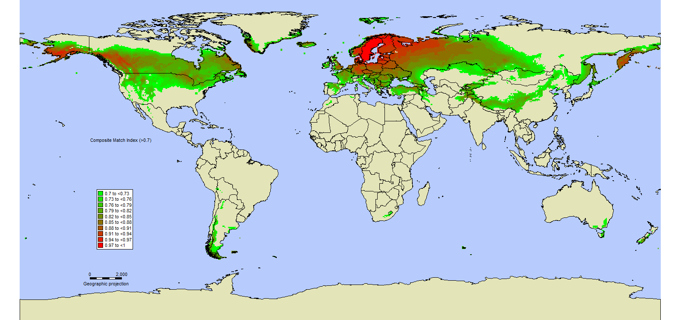
Composite match index (CMI) calculated based on the whole of Sweden using default values for the present climate using CLIMEX (Sutherst and Maywald 1985; Sutherst et al. 2007). Map kindly provided by Juha Tuomola.
EST2. In how large an area do the pest's host plants grow or are cultivated in the PRA area?

- All host plants that are considered threatened in EST1 should be taken into account.
- Only host plants supporting reproduction and establishment should be taken into account, e.g., areas where plants are present together if more than one host plant species is required, only host plants in regions where climate is suitable.

EXAMPLES OF WHAT THE DIFFERENT OPTIONS MEAN

- Not at all
- Host plants do not occur naturally or are not cultivated.

- Very small
- The production area of the threatened host plants is less than 100 ha.
- The pest threatens only one or a few ornamental plant species that are cultivated in greenhouses.
- The pest threatens only one wild plant that is very rare or occurs very locally.

- Small
- The production area of the threatened host plants is 100−1 000 ha.
- The pest threatens almost all greenhouse crops.

- Medium
- The production area of the threatened host plants is 1 000−10 000 ha.
- The pest threatens wild plants that are common, but do not occur throughout the PRA area.

- Large
- The production area of the threatened host plants is more than 10 000 ha.
- The pest threatens wild plants that are common, and occur almost throughout the whole PRA area.

EST3. How quickly would the pest likely spread in the PRA area?

- If the pest’s establishment and spread is dependent on its vector species, which is/are not present in the PRA area, the answer should be based on the organism (i.e. the pest or the vector) for which the rate of spread is slower.

TAKE INTO ACCOUNT
- The rate of natural spread and spread by human assistance
- The spatial distribution of host plants (i.e. the spatial arrangement of host plant patches, the size of the patches and the distances between them)
- The likelihood of (and the time needed for) transfer from one host species to another (e.g. from greenhouse ornamentals to potato fields)

EXAMPLES OF WHAT THE DIFFERENT OPTIONS MEAN

a. Very slowly
- The pest lives only in soil and does not spread by human assistance or with wind or water.
- The pest can disperse less than 10 m annually.
- The pest's host plants are produced in greenhouses, the places of production are located very far from each other, and the pest does not spread by human assistance.

b. Rather slowly
- The pest is likely to spread via tools within one farm from one field or greenhouse to another.
- The pest can disperse 10−1 000 m annually.
- The pest is likely to spread “rather quickly” on one of its host plant species, but a shift to another host species (e.g. from greenhouse to field crops) is likely to happen “rather slowly”.

c. Rather quickly
- The pest is likely to spread from one farm to another via large agricultural machinery.
- The pest can disperse 1−10 km annually.
- The pest is likely to spread “quickly” on one of its host plants, but a shift to another host species (e.g. from greenhouse to field crops) is likely to happen only “rather quickly”.

d. Quickly
- The pest is likely to spread with plant reproductive material from one farm to another.
- The pest can disperse more than 10 km annually, e.g. by active flight or wind, and its host plants’ occurrence does not limit its rate of spread.

EST4. Does the pest have characteristics that could assist in its establishment or spread in new areas?

The answer is determined by the number and importance of the following characteristics.
- The pest can reproduce asexually.
- The pest has a high reproductive rate or output.
- The pest can survive without host plants for rather long periods.
- The pest is able to actively locate host plants or mates from a long distance.
- The pest has several host plants from different plant families.
- The pest has been observed to rapidly acclimate or adapt to new conditions, e.g. it has developed new races or resistance to pesticides, or adapted to new host plants or climatic conditions.
- The pest has other characteristics that could assist in its establishment or spread in new areas.

a. No it does not
- The pest has none or one of the above-mentioned characteristics.

b. It has characteristics that could assist to some extent
- The pest has two of the above-mentioned characteristics.
- The pest has one of the above-mentioned characteristic that is likely to be of significant assistance.
- The pest has three of the above-mentioned characteristics, one or more of which are not likely to be of significant assistance.

c. It has characteristics that could assist to a great extent
- The pest has three of the above-mentioned characteristics.
- The pest has two of the above-mentioned characteristics, at least one of which is likely to be of significant assistance.
- The pest has four of the above-mentioned characteristics, one or more of which are not likely to be of significant assistance.

d. It has characteristics that could assist to a very great extent
- The pest has four or more of the above-mentioned characteristics.
- The pest has two or three of the above-mentioned characteristics, at least one of which is likely to be of significant assistance.

Characteristics that may assist to some extent are given 1 point, whereas those likely to provide significant assistance are given 2 points.
No it does not = 0–1 points
It has characteristics that could assist to some extent = 2–3 points
It has characteristics that could assist to a great extent = 4–5 points
It has characteristics that could assist to a very great extent = ≥ 6 points

IMPACT
IMP1. How significant are the direct economic losses that the pest would cause in the PRA area?

- It would not cause losses in the PRA area
- < 0.05 million € per year
- 0.05−0.1 million € per year
- 0.1−0.2 million € per year
- 0.2−0.4 million € per year
- 0.4−0.8 million € per year
- 0.8−1.5 million € per year
- 1.5−3 million € per year
- 3−6 million € per year
- 6−12 million € per year
- 12−25 million € per year
- 25−50 million € per year
- > 50 million € per year

- The assessment should be done assuming that the pest would be present in the entire area considered threatened in EST1 and EST2.
- Crop and quality losses should be estimated as the product of the total value of the threatened crops (in the threatened area) and the expected losses measured as a percentage.
- Pest control costs should be estimated as the product of the costs per area (€/ha) and the total production area (ha) of the threatened crops (in the threatened area).
- If the pest’s establishment and spread is dependent on its vector species the vector’s effect on the pest’s potential to cause economic losses should be taken into account.

TAKE INTO ACCOUNT
- All crop plants and forestry trees, ornamental plants and all the wild plants which can be utilized (e.g. wild berries), which the pest could damage
- Crop losses, quality losses, and the increase in pest control costs
- The effect of climate and other production conditions on the pest’s potential to cause losses

DO NOT TAKE INTO ACCOUNT
- Social or environmental impacts of any kind
- Costs incurred in the current situation by the control of other pests
- Costs incurred by eradication measures required by the plant health legislation
- Any losses caused by the vector species on its own

IMP2. Would the pest cause the following indirect economic impacts in the PRA area?

IMP2.1. Would the pest impact foreign trade?
IMP2.2. Is the pest a vector for other pests?
IMP2.3. Would the pest have a significant impact on the profitability of a plant production sector?

- All the questions are answered either yes or no.
- Only the host plants considered threatened in EST1 and EST2 should be taken into account.
- If the pest’s establishment and spread is dependent on its vector species the vector’s effect on the pest’s potential to cause indirect economic impacts (IMP2.1 and IMP2.3) should be taken into account.

- In IMP2.3 the pest’s impact should be considered to be
significant if
- there are no effective measures available to control the pest in the PRA area and without the control the pest would cause substantial crop or quality losses.
- the control of the pest would require implementation of measures that are not currently used in the PRA area in the considered sector of plant production.
insignificant if
the measures that are normally used to control other pests in the considered sector of plant production would effectively control the pest.

DO NOT TAKE INTO ACCOUNT
- Impacts caused by the vector species on its own.
- The size of the plant sector in relation to other plant sectors in the PRA area.

IMP3. How much direct impact would the pest have on the natural ecosystems in the PRA area?

- All host plants that occur naturally in the PRA area should be taken into account.
- The impacts caused by vector species on their own should not be taken into account.
- If the pest’s establishment and spread is dependent on its vector species, the vector’s effect on the pest’s potential to cause impacts on natural ecosystems should be taken into account.

EXAMPLES OF WHAT THE DIFFERENT OPTIONS MEAN

a. No impact
- The pest's host plants do not occur naturally in the PRA area.
- Some wild species are host plants, but no damage has been observed in natural environments in the area of the pest’s current distribution.
- The pest could damage some parts of wild plants, such as berries, but the damage would not kill the plants, and the damage would not hinder the functioning of the ecosystems.

b. Moderate impact
- The pest could kill individual wild plants in the PRA area, but the damage would not be likely to lead to a decrease in the host populations or hinder the functioning of the ecosystems.

c. Significant impact
The damages to wild plants in the PRA area could cause a decrease in the plant populations, or hinder the functioning of the ecosystems.

d. Very significant impact
- The damage to wild plants in the PRA area could cause the extinction or significant decrease of the host species, or cause significant damages to the ecosystems.

IMP4. Would the pest have the following environmental or social impacts in the PRA area?

IMP4.1. Social* impacts
IMP4.2. Significant aesthetic impacts
IMP4.3. An impact on plants which have an important, recognized position in the culture

- All the questions are answered either yes or no.
- Only hosts considered threatened in EST1 and EST2 should be taken into account.
- Social* impacts can be e.g. impacts on the amount or quality of food, construction materials and other goods gathered from nature, excluding aesthetic and cultural impact.
- Aesthetic impacts are caused by pests that have a significant negative effect on the visual perception of gardens, urban areas or landscapes (e.g., the impact of Dutch elm disease or the horse chestnut leaf miner).
- Cultural impact is an impact on plants, which have an important, recognized position in the Swedish culture, for example plant species included in traditional food (e.g., potato), folktales and poetry (e.g., ash in Nordic mythology) or plants with other symbolic values (e.g., “Landskapsblommor”).
- If the pest’s establishment and spread is dependent on its vector species, the vector’s effect on the pest’s potential to cause impacts should be taken into account.

* The term ‘Cultural’ was used in the original description – here changed to ‘social’ in order to distinguish this question from IMP4.3.

MANAGEMENT
Preventability

MAN1. Can the pest spread naturally to the PRA area from its current range during the next ten years?

- No it cannot
- It can, but it is unlikely or very unlikely*
- It can, but it is very unlikely
- It can, and it is likely or very likely
- It can, and it is very likely

- For instructions see ENT2 (natural spread).

*The original instruction had five answer options but only three, as written here, are found for the question in the model (Heikkilä et al. 2016; Marinova-Todorova et al. 2019).

MAN2. Is the pest present in the area of the European Union?

- Pests under eradication are not considered as present in the EU.

EXAMPLES OF WHAT THE DIFFERENT OPTIONS MEAN

a. No it is not

b. Yes, in a small area
- The pest’s distribution in the EU is either local or fragmented.
- The pest is present only in one to three member states

c. Yes, in a large area
- The pest is present in four or more member states.

MAN3. How difficult is it to detect the pest during inspections?

- Both the inspections in the country of origin and import inspections should be taken into account.

EXAMPLES OF WHAT THE DIFFERENT OPTIONS MEAN

a. Easy
- The pest always causes easily detectable symptoms in plants.
- The pest is large and easily visually detectable.

b. Difficult
- The pest may be present on plants for a short time without causing symptoms.
- The pest causes symptoms that are visually difficult to tell apart from symptoms caused by other pests.

c. Nearly impossible
- The pest may be present on plants for a long time without causing any symptoms.
- The pest lives inside the plant during some stages of its lifecycle so that detecting it is impossible without destroying the plant.

Controllability

MAN4. How difficult would it be to eradicate the pest from the PRA area?

EXAMPLES OF WHAT THE DIFFERENT OPTIONS MEAN

a. Easy
- The pest cannot survive outside its host plants, and eradication of the host plants would be easy.
- The pest’s host plants are only cultivated in greenhouses and the pest can be eradicated with a short, e.g. a few months, break in cultivation.

b. Rather difficult
- The needed eradication methods are expensive or difficult to implement, e.g. the destruction of a large area of field crops or implementation of a long, e.g. over one year, break in cultivation.

c. Very difficult
- The pest’s host plants are cultivated on open land and the needed eradication methods are very expensive or nearly impossible to implement, e.g. the destruction of a large area of woody plants.

d. Impossible
- The pest is able to survive in the soil for years without a host plant.
- The pest can spread into natural environments.
- The pest has several potential host plants growing on open land.

MAN5. How difficult would it be to survey the pest's occurrence in the PRA area?

TAKE INTO ACCOUNT
- The pest’s natural potential to spread
- The abundance and the distribution of host plants
- The detectability of the pest
- The availability and efficacy of survey methods

EXAMPLES OF WHAT THE DIFFERENT OPTIONS MEAN

a. Easy
- The pest is easy to detect, and its host plants grow or are cultivated so sparsely, that they can be comprehensively surveyed.
- The pest is very unlikely to spread and effective survey methods are available.

b. Rather difficult
- The pest is easy to detect, but its host plants grow or are cultivated so commonly that their comprehensive surveying would be difficult.
- The pest is difficult to detect and no effective survey methods are available, but host plants grow or are cultivated so sparsely that they can be rather comprehensively surveyed.

c. Very difficult
- The pest spreads rather quickly, is difficult to detect, and no effective survey methods are available.

d. Impossible
- The pest spreads very quickly and its host plants are widely present, e.g. common forest trees.

REFERENCES
Heikkilä, J., Tuomola, J., Pouta, E., & Hannunen, S. (2016). FinnPRIO: a model for ranking invasive plant pests based on risk. Biological Invasions, 18(7), 1827-1842.
Marinova-Todorova, Mariela, Tuomola, Juha, Heikkilä, Jaakko, & Hannunen, Salla. (2019, May 13). A Graphical User Interface for the FinnPRIO model: A model for ranking plant pests based on risk (Version 1.0). Zenodo. http://doi.org/10.5281/zenodo.2784027
Sutherst, R. W., & Maywald, G. F. (1985). A computerised system for matching climates in ecology. Agriculture, Ecosystems & Environment, 13(3-4), 281-299.
Sutherst R, Maywald G, Kriticos D (2007) Climex Version 3 User’s Guide. Hearne Scientific Software Pty Ltd, South Yarra

Appendix 2. Filtering options in HTML-versions of the figures

In the HTML-file versions of Figures 2 and 3, a selection of pests can be visualized based on different categories.
The options “Pest group”, “present in the EU” and “Quarantine status” are self-explanatory and consist of mutually exclusive categories.
The pests can also be filtered based on the crops/plants they threaten in the following categories: conifers, broadleaved trees, potato, cereals, oil-bearing crops, other arable crops, fruit and berries, open-field vegetables, outdoor ornamental plants, greenhouse vegetables, greenhouse ornamentals and wild plants. The pests can belong to more than one category.

Appendix 3. List of all the assessed species/genera and date of assessment
Pest name | EPPO code |  | Assessment date
Acleris minuta | ACLRMI | 18.06.2025
Acleris nishidai | ACLRNI | 18.06.2025
Acleris nivisellana | ACLRNV | 18.06.2025
Acleris semipurpurana | CROISE | 18.06.2025
Acleris senescens | ACLRSE | 18.06.2025
Acrobasis pirivorella | NUMOPI | 08.10.2021
Agrilus anxius | AGRLAX | 31.03.2021
Agrilus fleischeri | AGRLFL | 11.06.2021
Agrilus planipennis | AGRLPL | 04.06.2021
Anoplophora chinensis | ANOLCN | 05.05.2021
Anoplophora glabripennis | ANOLGL | 18.06.2025
Anthonomus eugenii | ANTHEU | 11.06.2021
Anthonomus quadrigibbus | TACYQU | 17.05.2021
Arceuthobium spp. | 1AREG | 20.03.2025
Aromia bungii | AROMBU | 11.06.2021
Arrhenodes minutus | ARRHMI | 31.05.2021
Aschistonyx eppoi | ASCXEP | 10.06.2021
Atropellis spp. | 1ATRPG | 16.06.2021
Bactericera cockerelli | PARZCO | 19.12.2025
Bemisia tabaci | BEMITA | 28.05.2021
Bretziella fagacearum | CERAFA | 29.04.2021
Bursaphelenchus xylophilus (Current Climate) | BURSXY | 05.05.2021
Bursaphelenchus xylophilus (Future Climate) | BURSXY | 28.04.2021
Candidatus phytoplasma americanum | PHYPAE | 18.12.2025
Carposina sasakii | CARSSA | 13.06.2021
Ceratocystis platani | CERAFP | 01.02.2022
Choristoneura conflictana | ARCHCO | 17.06.2025
Choristoneura fumiferana | CHONFU | 13.08.2024
Choristoneura parallela | CHONPA | 13.08.2024
Choristoneura pinus | CHONPI | 17.06.2025
Choristoneura rosaceana | CHONRO | 17.06.2025
Chrysomyxa arctostaphyli | CHMYAR | 08.02.2022
Clavibacter sepedonicus | CORBSE | 19.03.2025
Comovirus andesense | APMOV0 | 18.12.2025
Coniferiporia sulphurascens | PHELSU | 06.05.2021
Coniferiporia weirii | INONWE | 06.05.2021
Conotrachelus nenuphar | CONHNE | 11.06.2021
Contarinia pseudotsugae | CONTPS | 14.06.2021
Crisicoccus pini | DACLYPI | 28.03.2022
Cronartium spp. | 1CRONG | 29.06.2021
Cryphonectria parasitica | ENDOPA | 29.06.2021
Curtobacterium flaccumfaciens pv. flaccumfaciens | CORBFL | 20.03.2025
Davidsoniella virescens | CERAVI | 02.02.2022
Dendroctonus rufipennis | DENCRU | 30.06.2021
Dendroctonus valens | DENCVA | 30.06.2021
Dendrolimus sibiricus | DENDSI | 24.09.2021
Diabrotica undecimpunctata howardi | DIABUH | 18.06.2025
Diabrotica virgifera zeae | DIABVZ | 17.03.2025
Emaravirus rosae | RRV000 | 13.08.2024
Epitrix cucumeris | EPIXCU | 19.12.2025
Epitrix papa | EPIXPP | 02.02.2026
Epitrix subcrinita | EPIXSU | 19.12.2025
Epitrix tuberis | EPIXTU | 19.12.2025
Fusarium circinatum | GIBBCI | 13.08.2024
Geosmithia morbida | GEOHMO | 10.02.2022
Globodera pallida | HETDPA | 19.12.2025
Globodera rostochiensis | HETDRO | 19.12.2025
Grapholita inopinata | CYDIIN | 23.06.2021
Grapholita packardi | LASPPA | 18.08.2021
Grapholita prunivora | LASPPR | 16.06.2021
Gymnosporangium spp. | 1GYMNG | 07.06.2021
Helicoverpa zea | HELIZE | 17.03.2025
Ips confusus | IPSXCO | 08.10.2021
Ips hauseri | IPSXHA | 05.01.2022
Keiferia lycopersicella | GNORLY | 13.08.2024
Leptinotarsa decemlineata | LPTNDE | 19.12.2025
Listronotus bonariensis | HYROBO | 17.03.2025
Lopholeucaspis japonica | LOPLJA | 20.03.2025
Melampsora farlowii | MELMFA | 26.05.2021
Melampsora medusae f.sp. tremuloidis | MELMMT | 29.08.2024
Meloidogyne chitwoodi | MELGCH | 19.12.2025
Meloidogyne fallax | MELGFA | 18.12.2025
Monochamus spp. (non-European populations) | 1MONCG | 28.04.2021
Naupactus leucoloma | GRAGLE | 19.12.2025
Nepovirus myrtilli | BLMOV0 | 13.08.2024
Nepovirus solani | PBRSV0 | 18.12.2025
Oemona hirta | OEMOHI | 18.06.2025
Pissodes cibriani | PISOCI | 15.08.2024
Pissodes fasciatus | PISOFA | 15.08.2024
Pissodes nemorensis | PISONE | 14.08.2024
Pissodes nitidus | PISONI | 15.08.2024
Pissodes punctatus | PISOPU | 14.08.2024
Pissodes strobi | PISOST | 03.05.2021
Pissodes terminalis | PISOTE | 14.08.2024
Pissodes yunnanensis | PISOYU | 14.08.2024
Pissodes zitacuarense | PISOZI | 14.08.2024
Pityophthorus juglandis | PITOJU | 20.09.2021
Polygraphus proximus | POLGPR | 13.08.2024
Popillia japonica | POPIJA | 29.04.2025
Porphyrophora tritici | PORPTR | 17.06.2025
Prodiplosis longifila | PRDILO | 17.06.2025
Pseudocercospora pini-densiflorae | CERSPD | 13.08.2024
Puccinia pittieriana | PUCCPT | 18.12.2025
Pucciniastrum minimum | THEKMI | 13.08.2024
Ralstonia pseudosolanacearum | RALSPS | 19.03.2025
Ralstonia solanacearum | RALSSL | 19.03.2025
Rhagoletis pomonella | RHAGPO | 11.06.2021
Sphaerulina musiva | MYCOPP | 13.08.2024
Spodoptera litura | PRODLI | 17.03.2025
Stagonosporopsis andigena | PHOMAN | 18.12.2025
Synchytrium endobioticum | SYNCEN | 29.04.2021
Tecia solanivora | TECASO | 19.12.2025
Thrips palmi | THRIPL | 19.03.2025
Tilletia indica | NEOVIN | 19.03.2025
Toumeyella parvicornis | TOUMPA | 30.04.2025
Tymovirus latandigenum | APLV00 | 18.12.2025
Tymovirus mosandigenum | APMMV0 | 18.12.2025
Xiphinema californicum | XIPHCA | 11.06.2021
Xylella fastidiosa | XYLEFA | 20.03.2025

Appendix 4. Summary statistics
The ranking of assessed pests based on different summary statistics of the probability distributions of the scores may change dependning on the selected statistics, e.g. mean or median values. However, the differences between the mean and median values of the FinnPRIO scores for assessed pests are small (Figure A1). The differences between the mean and median FinnPRIO scores for both invasion and impact are also small (data not shown).
The change in ranked order when the FinnPRIO risk score is calculated using the median rather than the mean is also rather limited, e.g., the top 15 positions remained unchanged (Table 1). Small shifts occur as the risk scores decrease and larger shifts were only found for pests with very low risk scores. For these species the specific ranking order may have little practical implication.
It should be noted that these results were obtained using a PERT distribution with the lambda parameter set to four, which places relatively high weight on the most likely value and reduces the influence of the minimum and maximum. Using a lower lambda would place more weight on the extremes, resulting in more skewed distributions and larger differences between mean and median scores.

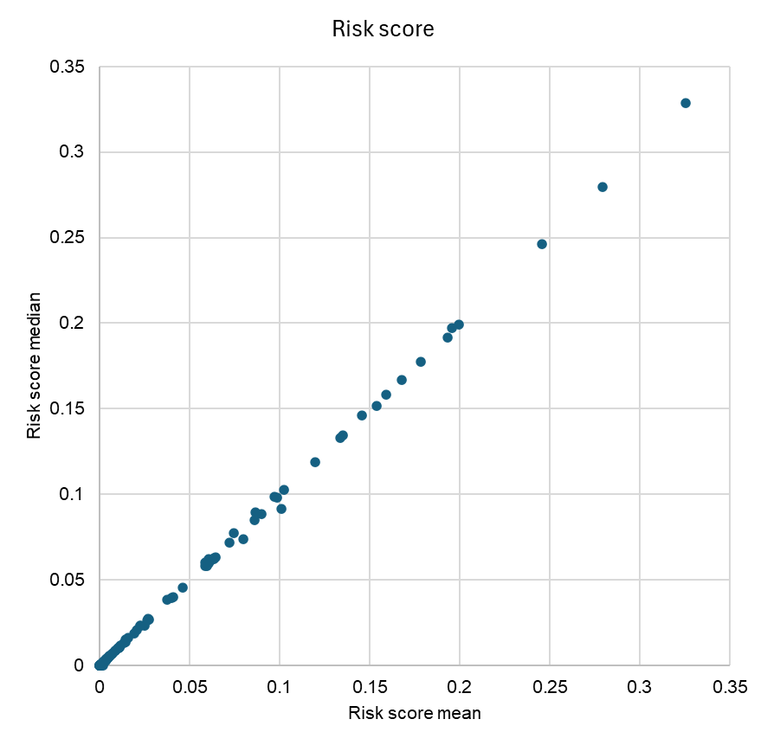
Figure 1. The FinnPRIO risk scores for the pests included in Björklund and Boberg (2025) calculated as means plotted against the corresponding scores calculated as medians. The scores were generated by the FinnPRIO GUI (Marinova-Todorova et al. 2019) using 25 000 iterations.

Table 1. Assessed pests from Björklund and Boberg 2025, ranked based on the FinnPRIO risk score calculated as a mean value (A) or a median value (B). The change in rank order when using median values instead of mean values is also provided as the number of steps moved up or down in the list. Note that this analysis did not include pests assessed after the publication of Björklund and Boberg (2025).

A. Pest list sorted based on risk score mean values B. Pest list sorted based on risk score median values
Rank No. | Pest name | mean value |  | Rank No. | Pest name | median value | Rank order change
1 | Agrilus planipennis [AGRLPL] | 0.3255997 |  | 1 | Agrilus planipennis [AGRLPL] | 0.3286209
2 | Ralstonia solanacearum [RALSSL] | 0.2795407 |  | 2 | Ralstonia solanacearum [RALSSL] | 0.2795151
3 | Popillia japonica [POPIJA] | 0.2455447 |  | 3 | Popillia japonica [POPIJA] | 0.2461105
4 | Bursaphelenchus xylophilus [BURSXY] FC | 0.1996864 |  | 4 | Bursaphelenchus xylophilus [BURSXY] FC | 0.1992993
5 | Clavibacter sepedonicus [CORBSE] | 0.1955788 |  | 5 | Clavibacter sepedonicus [CORBSE] | 0.1973473
6 | Listronotus bonariensis [HYROBO] | 0.1932804 |  | 6 | Listronotus bonariensis [HYROBO] | 0.1918477
7 | Toumeyella parvicornis [TOUMPA] | 0.1786003 |  | 7 | Toumeyella parvicornis [TOUMPA] | 0.1773848
8 | Ralstonia pseudosolanacearum [RALSPS] | 0.1679499 |  | 8 | Ralstonia pseudosolanacearum [RALSPS] | 0.1666743
9 | Bemisia tabaci [BEMITA] | 0.1592300 |  | 9 | Bemisia tabaci [BEMITA] | 0.1582191
10 | Pucciniastrum minimum [THEKMI] | 0.1537830 |  | 10 | Pucciniastrum minimum [THEKMI] | 0.1519285
11 | Dendrolimus sibiricus [DENDSI] | 0.1457011 |  | 11 | Dendrolimus sibiricus [DENDSI] | 0.1462117
12 | Curtobacterium flaccumfaciens pv. laccumfaciens [CORBFL] | 0.1352670 |  | 12 | Curtobacterium flaccumfaciens pv. flaccumfaciens [CORBFL] | 0.1343891
13 | Meloidogyne chitwoodi [MELGCH] | 0.1336615 |  | 13 | Meloidogyne chitwoodi [MELGCH] | 0.1332517
14 | Anoplophora glabripennis [ANOLGL] | 0.1196925 |  | 14 | Anoplophora glabripennis [ANOLGL] | 0.1187300
15 | Pissodes nitidus [PISONI] | 0.1026280 |  | 15 | Pissodes nitidus [PISONI] | 0.1029158
16 | Synchytrium endobioticum [SYNCEN] | 0.1009617 |  | 16 | Fusarium circinatum [GIBBCI] | 0.0985739 | 2↑
17 | Globodera rostochiensis [HETDRO] | 0.0988203 |  | 17 | Globodera rostochiensis [HETDRO] | 0.0981387
18 | Fusarium circinatum [GIBBCI] | 0.0969891 |  | 18 | Synchytrium endobioticum [SYNCEN] | 0.0917583 | 2↓
19 | Cryphonectria parasitica [ENDOPA] | 0.0899230 |  | 19 | Choristoneura fumiferana [CHONFU] | 0.0894649 | 1↑
20 | Choristoneura fumiferana [CHONFU] | 0.0866010 |  | 20 | Cryphonectria parasitica [ENDOPA] | 0.0886168 | 1↓
21 | Dendroctonus rufipennis [DENCRU] | 0.0859714 |  | 21 | Dendroctonus rufipennis [DENCRU] | 0.0848788
22 | Thrips palmi [THRIPL] | 0.0799335 |  | 22 | Cronartium spp. [1CRONG] | 0.0771780 | 1↑
23 | Cronartium spp. [1CRONG] | 0.0746457 |  | 23 | Thrips palmi [THRIPL] | 0.0738743 | 1↓
24 | Polygraphus proximus [POLGPR] | 0.0720713 |  | 24 | Polygraphus proximus [POLGPR] | 0.0719240
25 | Ips hauseri [IPSXHA] | 0.0642458 |  | 25 | Ips hauseri [IPSXHA] | 0.0630481
26 | Dendroctonus valens [DENCVA] | 0.0637168 |  | 26 | Gymnosporangium spp. [1GYMNG] | 0.0626548 | 1↑
27 | Gymnosporangium spp. [1GYMNG] | 0.0634075 |  | 27 | Pissodes strobi [PISOST] | 0.0624606 | 2↑
28 | Pissodes nemorensis [PISONE] | 0.0614160 |  | 28 | Dendroctonus valens [DENCVA] | 0.0622807 | 2↓
29 | Pissodes strobi [PISOST] | 0.0607278 |  | 29 | Pissodes nemorensis [PISONE] | 0.0609971 | 1↓
30 | Tilletia indica [NEOVIN] | 0.0604574 |  | 30 | Anoplophora chinensis [ANOLCN] | 0.0599630 | 2↑
31 | Agrilus anxius [AGRLAX] | 0.0596891 |  | 31 | Tilletia indica [NEOVIN] | 0.0599424 | 1↓
32 | Anoplophora chinensis [ANOLCN] | 0.0588066 |  | 32 | Epitrix papa [EPIXPP] | 0.0582002 | 1↑
33 | Epitrix papa [EPIXPP] | 0.0586602 |  | 33 | Agrilus anxius [AGRLAX] | 0.0581122 | 2↓
34 | Crisicoccus pini [DACLYPI] | 0.0463962 |  | 34 | Crisicoccus pini [DACLYPI] | 0.0453339
35 | Monochamus spp. (non-European populations) [1MONCG] | 0.0407411 |  | 35 | Monochamus spp. (non-European populations) [1MONCG] | 0.0401250
36 | Diabrotica undecimpunctata howardi [DIABUH] | 0.0400312 |  | 36 | Diabrotica undecimpunctata howardi [DIABUH] | 0.0394679
37 | Choristoneura pinus [CHONPI] | 0.0375185 |  | 37 | Choristoneura pinus [CHONPI] | 0.0385467
38 | Lopholeucaspis japonica [LOPLJA] | 0.0276502 |  | 38 | Arrhenodes minutus [ARRHMI] | 0.0272573 | 2↑
39 | Pissodes punctatus [PISOPU] | 0.0270621 |  | 39 | Pissodes punctatus [PISOPU] | 0.0269847
40 | Arrhenodes minutus [ARRHMI] | 0.0270213 |  | 40 | Lopholeucaspis japonica [LOPLJA] | 0.0269245 | 2↓
41 | Oemona hirta [OEMOHI] | 0.0263955 |  | 41 | Oemona hirta [OEMOHI] | 0.0261711
42 | Bursaphelenchus xylophilus [BURSXY] CC | 0.0250991 |  | 42 | Bursaphelenchus xylophilus [BURSXY] CC | 0.0233788
43 | Choristoneura rosaceana [CHONRO] | 0.0227585 |  | 43 | Choristoneura rosaceana [CHONRO] | 0.0232889
44 | Chrysomyxa arctostaphyli [CHMYAR] | 0.0224351 |  | 44 | Chrysomyxa arctostaphyli [CHMYAR] | 0.0230990
45 | Xylella fastidiosa [XYLEFA] | 0.0206462 |  | 45 | Xylella fastidiosa [XYLEFA] | 0.0206960
46 | Aromia bungii [AROMBU] | 0.0191020 |  | 46 | Aromia bungii [AROMBU] | 0.0187159
47 | Conotrachelus nenuphar [CONHNE] | 0.0159705 |  | 47 | Conotrachelus nenuphar [CONHNE] | 0.0160700
48 | Sphaerulina musiva [MYCOPP] | 0.0146149 |  | 48 | Xiphinema californicum [XIPHCA] | 0.0150155 | 1↑
49 | Xiphinema californicum [XIPHCA] | 0.0144994 |  | 49 | Sphaerulina musiva [MYCOPP] | 0.0137175 | 1↓
50 | Coniferiporia sulphurascens [PHELSU] | 0.0134738 |  | 50 | Coniferiporia sulphurascens [PHELSU] | 0.0131773
51 | Keiferia lycopersicella [GNORLY] | 0.0117330 |  | 51 | Keiferia lycopersicella [GNORLY] | 0.0116758
52 | Choristoneura parallela [CHONPA] | 0.0112591 |  | 52 | Emaravirus rosae [RRV000] | 0.0108597 | 1↑
53 | Emaravirus rosae [RRV000] | 0.0111620 |  | 53 | Choristoneura parallela [CHONPA] | 0.0106641 | 1↓
54 | Bretziella fagacearum [CERAFA] | 0.0104860 |  | 54 | Bretziella fagacearum [CERAFA] | 0.0102357
55 | Acleris minuta [ACLRMI] | 0.0102903 |  | 55 | Acleris minuta [ACLRMI] | 0.0101100
56 | Grapholita inopinata [CYDIIN] | 0.0088187 |  | 56 | Grapholita inopinata [CYDIIN] | 0.0088234
57 | Potato black ringspot virus [PBRSV0] | 0.0087413 |  | 57 | Potato black ringspot virus [PBRSV0] | 0.0087328
58 | Anthonomus eugenii [ANTHEU] | 0.0073564 |  | 58 | Anthonomus eugenii [ANTHEU] | 0.0072208
59 | Pissodes zitacuarense [PISOZI] | 0.0066773 |  | 59 | Pissodes zitacuarense [PISOZI] | 0.0065890
60 | Grapholita prunivora [LASPPR] | 0.0059250 |  | 60 | Grapholita prunivora [LASPPR] | 0.0057665
61 | Nepovirus myrtilli [BLMOV0] | 0.0055021 |  | 61 | Nepovirus myrtilli [BLMOV0] | 0.0053766
62 | Coniferiporia weirii [INONWE] | 0.0049233 |  | 62 | Coniferiporia weirii [INONWE] | 0.0047681
63 | Agrilus fleischeri [AGRLFL] | 0.0047423 |  | 63 | Agrilus fleischeri [AGRLFL] | 0.0047120
64 | Rhagoletis pomonella [RHAGPO] | 0.0043983 |  | 64 | Rhagoletis pomonella [RHAGPO] | 0.0042782
65 | Choristoneura conflictana [ARCHCO] | 0.0042592 |  | 65 | Choristoneura conflictana [ARCHCO] | 0.0041965
66 | Pissodes terminalis [PISOTE] | 0.0040179 |  | 66 | Pissodes terminalis [PISOTE] | 0.0041638
67 | Ceratocystis platani [CERAFP] | 0.0037304 |  | 67 | Atropellis spp. [1ATRPG] | 0.0037651 | 1↑
68 | Atropellis spp. [1ATRPG] | 0.0037257 |  | 68 | Ceratocystis platani [CERAFP] | 0.0037273 | 1↓
69 | Carposina sasakii [CARSSA] | 0.0036538 |  | 69 | Carposina sasakii [CARSSA] | 0.0036909
70 | Pseudocercospora pini-densiflorae [CERSPD] | 0.0035268 |  | 70 | Pseudocercospora pini-densiflorae [CERSPD] | 0.0035546
71 | Contarinia pseudotsugae [CONTPS] | 0.0032560 |  | 71 | Contarinia pseudotsugae [CONTPS] | 0.0027998
72 | Grapholita packardi [LASPPA] | 0.0027890 |  | 72 | Grapholita packardi [LASPPA] | 0.0025575
73 | Acleris semipurpurana [CROISE] | 0.0025791 |  | 73 | Acleris semipurpurana [CROISE] | 0.0025481
74 | Acleris nivisellana [ACLRNV] | 0.0018750 |  | 74 | Acleris nivisellana [ACLRNV] | 0.0019379
75 | Spodoptera litura [PRODLI] | 0.0017605 |  | 75 | Geosmithia morbida [GEOHMO] | 0.0017247 | 1↑
76 | Geosmithia morbida [GEOHMO] | 0.0017094 |  | 76 | Pityophthorus juglandis [PITOJU] | 0.0015330 | 1↑
77 | Pityophthorus juglandis [PITOJU] | 0.0015250 |  | 77 | Acleris nishidai [ACLRNI] | 0.0007972 | 2↑
78 | Helicoverpa zea [HELIZE] | 0.0010939 |  | 78 | Pissodes fasciatus [PISOFA] | 0.0007069 | 2↑
79 | Acleris nishidai [ACLRNI] | 0.0008033 |  | 79 | Melampsora farlowii [MELMFA] | 0.0006658 | 2↑
80 | Pissodes fasciatus [PISOFA] | 0.0007487 |  | 80 | Acrobasis pirivorella [NUMOPI] | 0.0006041 | 2↑
81 | Melampsora farlowii [MELMFA] | 0.0006772 |  | 81 | Anthonomus quadrigibbus [TACYQU] | 0.0004240 | 2↑
82 | Acrobasis pirivorella [NUMOPI] | 0.0006183 |  | 82 | Acleris senescens [ACLRSE] | 0.0003331 | 3↑
83 | Anthonomus quadrigibbus [TACYQU] | 0.0004349 |  | 83 | Davidsoniella virescens [CERAVI] | 0.0002083 | 4↑
84 | Arceuthobium spp. [1AREG] | 0.0004231 |  | 84 | Porphyrophora tritici [PORPTR] | 0.0001042 | 5↑
85 | Acleris senescens [ACLRSE] | 0.0003780 |  | 85 | Pissodes yunnanensis [PISOYU] | 0.0000008 | 5↑
86 | Diabrotica virgifera zeae [DIABVZ] | 0.0003665 |  | 86 | Arceuthobium spp. [1AREG] | 0 | ↓*
87 | Davidsoniella virescens [CERAVI] | 0.0002053 |  | 86 | Aschistonyx eppoi [ASCXEP] | 0
88 | Prodiplosis longifila [PRDILO] | 0.0001961 |  | 86 | Diabrotica virgifera zeae [DIABVZ] | 0 | ↓*
89 | Porphyrophora tritici [PORPTR] | 0.0001573 |  | 86 | Helicoverpa zea [HELIZE] | 0 | ↓*
90 | Pissodes yunnanensis [PISOYU] | 0.0000160 |  | 86 | Ips confusus [IPSXCO] | 0
91 | Melampsora medusae f.sp. tremuloidis [MELMMT] | 0.0000005 |  | 86 | Melampsora medusae f.sp. tremuloidis [MELMMT] | 0 | ↓*
92 | Aschistonyx eppoi [ASCXEP] | 0 |  | 86 | Pissodes cibriani [PISOCI] | 0
92 | Ips confusus [IPSXCO] | 0 |  | 86 | Prodiplosis longifila [PRDILO] | 0 | ↓*
92 | Pissodes cibriani [PISOCI] | 0 |  | 86 | Spodoptera litura [PRODLI] | 0 | ↓*

* Species with median value of 0 and a mean value of > 0. These species have the same rank and it is not feasible to count the rank change.

The PERT distribution (named after the Program Evaluation and Review Technique) is a smooth, continuous probability distribution defined by three parameters: the minimum, maximum, and most likely values. It is often used in risk analysis as an alternative to the triangular distribution, since it places less weight on the extreme values and more around the most likely value (cf. Salling and Banister 2010).
Specifically, the questions ENT3 (trade volumes), EST2 (host plant areas), and IMP1 (direct economic losses), as defined in Appendix 1.
Question EST1 = Could the pest reproduce and overwinter in the PRA area taking into account the climate and production conditions?
Commission Implementing Regulation (EU) 2019/2072. ELI: http://data.europa.eu/eli/reg_impl/2019/2072/oj
Agrilus anxius, Agrilus planipennis, Anthonomus eugenii, Bursaphelenchus xylophilus, Ceratocystis fagacearum, Coniferiporia weirii, Conotrachelus nenuphar, Cryphonectria parasitica, Epitrix papa, Globodera rostochiensis, Meloidogyne chitwoodi, Monochamus spp., Phytophthora ramorum, Pissodes strobi, Nepovirus solani, Rhagoletis pomonella, Synchytrium endobioticum and Xiphinema californicum.
Commission Implementing Regulation (EU) 2024/2004, ELI: http://data.europa.eu/eli/reg_impl/2024/2004/oj
It may be noted that FinnPRIO also allows for the calculation of an invasion score without official management measures, which makes it possible to evaluate their impact.
Commission Implementing Regulation (EU) 2019/2072. ELI: http://data.europa.eu/eli/reg_impl/2019/2072/oj
Commission Implementing Regulation (EU) 2018/2019. ELI: http://data.europa.eu/eli/reg_impl/2018/2019/oj

